**BASIC QUESTIONS (Attempt any 8) :**

1.How many unique students are included in the dataset ?

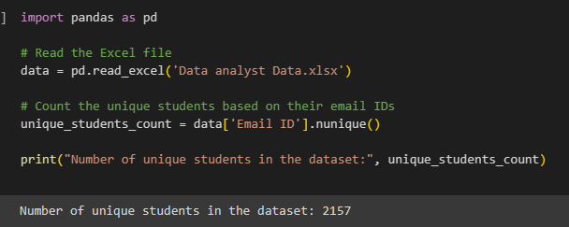

2.What is the Average GPA of students ?

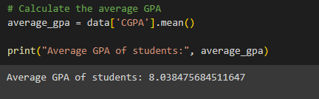

3.what is the distribution of students across different graduation years ?

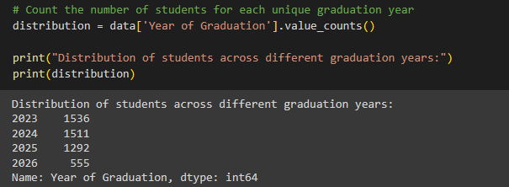

4.What is the distribution of students experience with python programming ?

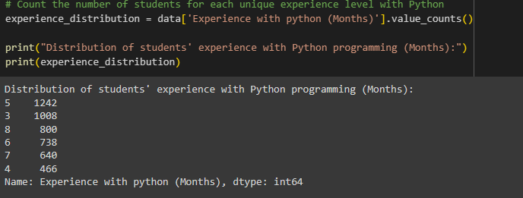

5. What is the average family income of the student ?

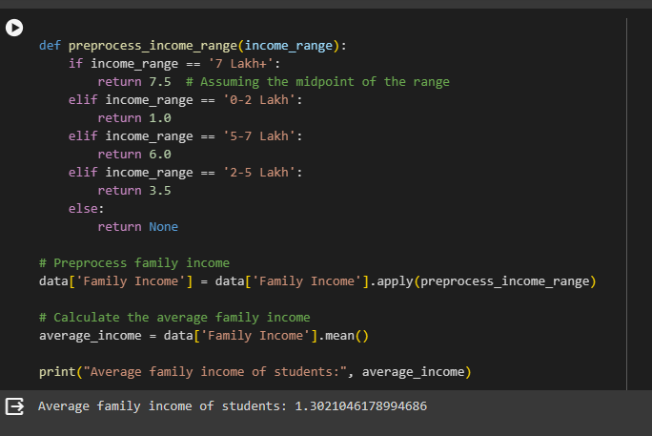

6. How does the GPA vary among different colleges ? (show up to 5 results only)

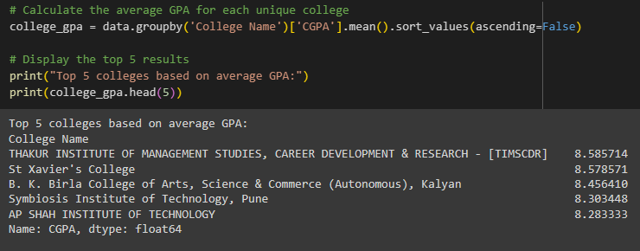

7. Are there any outliers in the quantity (number of courses completed) attribute ?

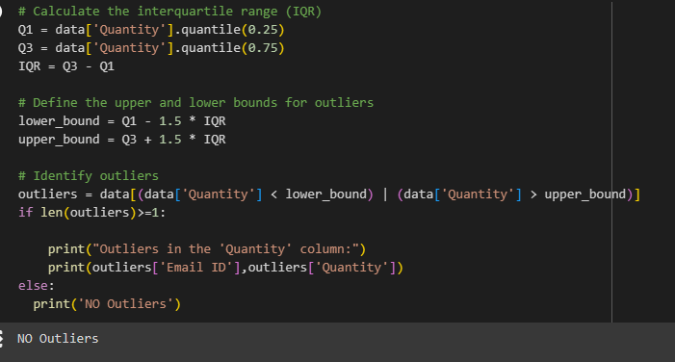

8. What is the average GPA for student from each city ?

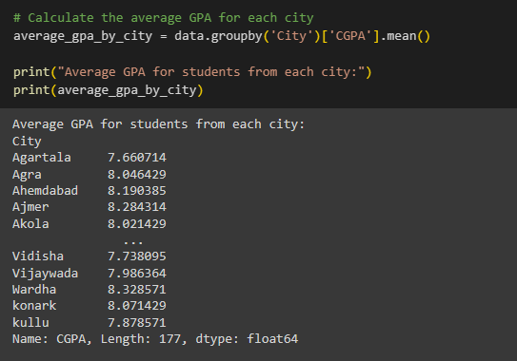

**MODERATE QUESTIONS (Attempt any 8) :**

10. How many students from various cities ? (Solve using data visualization tool)

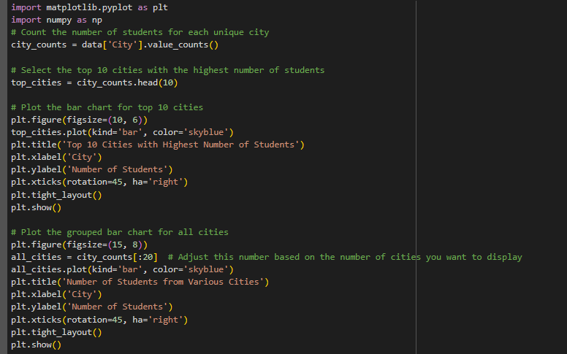

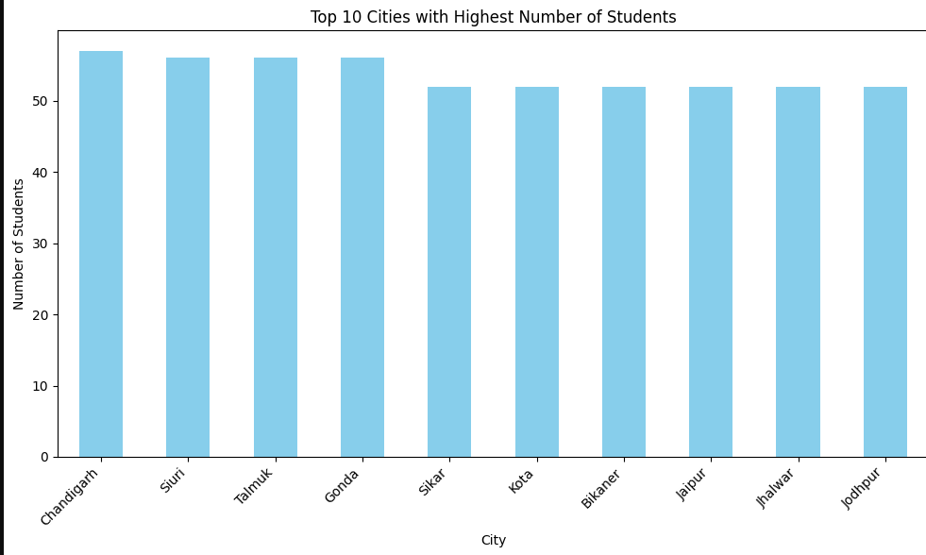

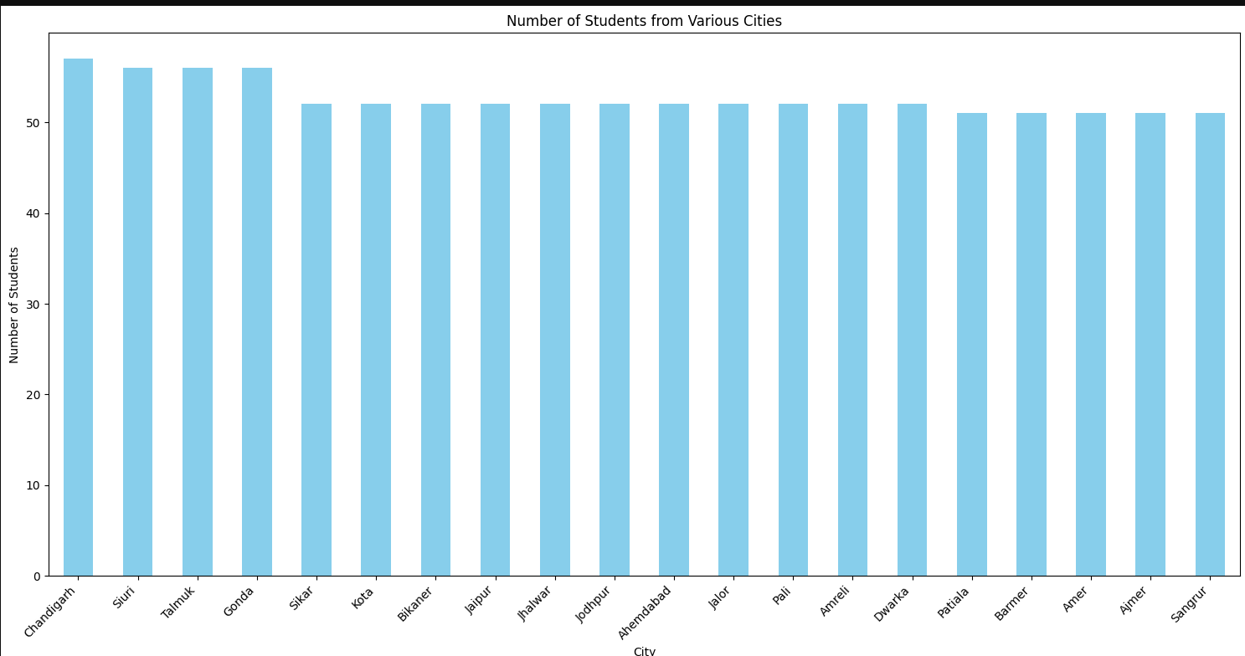

11. How does the expected salary vary based on factors like GPA, Family Income, Experience with python ?

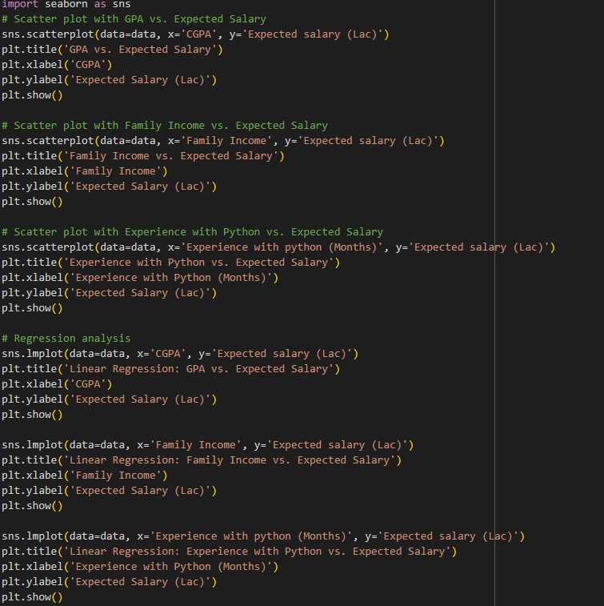

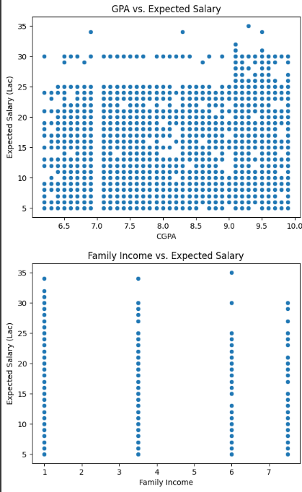

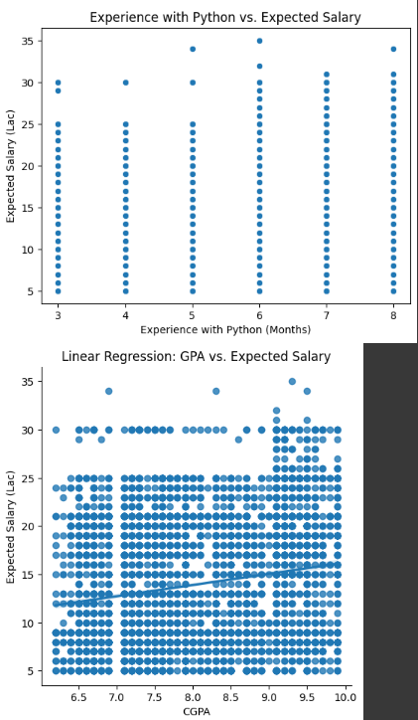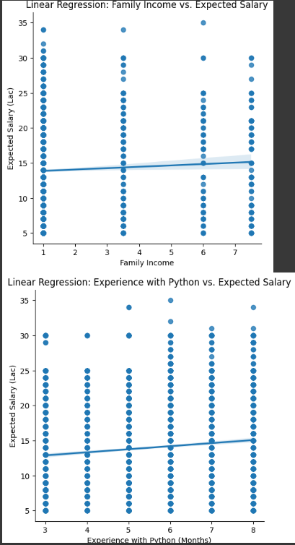

12. Which event tend to attract more students from specific field of study ?

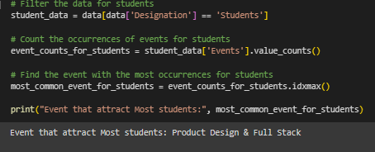

13. Do students In Leadership Position during their college years tend to have higher GPAs or better expected salary ?

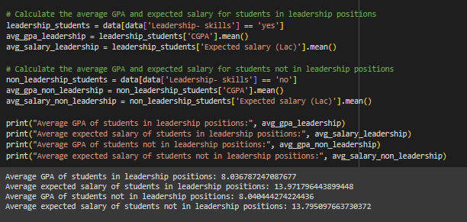

14. How many students are Graduating by the end of 2024 ?

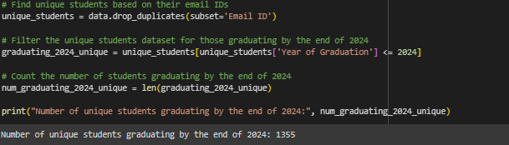

15. Which Promotion channel brings in more student participations for the event ?

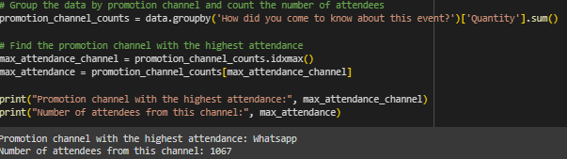

16. .Find the total number of students who attended the events related to Data Science (From all Data science related courses)

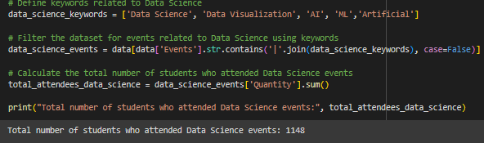

17. Those who have high CGPA and More experience in language those who had high expectations for salary? (AVG)

